Проверочная работа
по АНГЛИЙСКОМУ ЯЗЫКУ
7 КЛАСС

Дата: ___ ___ 20__ г.
Вариант №: ___

Выполнена: ФИО_________________________________

Инструкция по выполнению работы
На выполнение работы по английскому языку даётся 45 минут. Работа включает
в себя 6 заданий.

Желаем успеха!

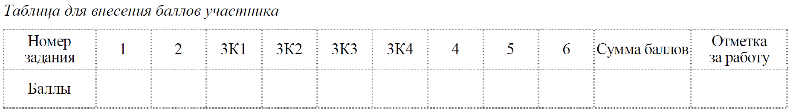

Перед Вами 5 предложений A – E с пропусками и варианты слов или словосочетаний для заполнения этих пропусков, обозначенные цифрами 1 – 3. Внимательно прочитайте их. Вы услышите диалог. Для каждого предложения A – E выберите слово или словосочетание, соответствующее содержанию диалога. К каждому пропуску подходит только одно слово или словосочетание. Вы услышите запись дважды. При повторном прослушивании проверьте себя. У Вас есть 45 секунд, чтобы ознакомиться с предложениями.

1

А. The gym starts working at _________ .
1) 9:30 am; 2) 8:30 am; 3) 8 am

B. The weather is _________ today.
1) warm; 2) cold; 3) hot

C. A big hot drink costs _________ .
1) $1; 2) 40 cents; 3) $1,40

D. The lady orders _________ jam with her tea.
1) orange; 2) strawberry; 3) apple

E. The lady likes the picture _________.
1) under the clock; 2) In front of the clock; 3) in front of the window
Запишите в таблицу выбранные цифры под соответствующими буквами.
Ответ:
A | B | C | D | E

2

Прочитайте текст вслух. У вас есть полторы минуты на подготовку и полторы минуты, чтобы прочитать текст вслух.
In the past, wealthy people travelled to distant parts of the world to see great buildings, works of art, learn new languages, experience new cultures, and taste different cuisines. During the Roman Republic, coastal resorts were popular among the rich. Modern tourism can be traced to what was known as the Grand Tour, which was a traditional trip around Europe, especially Germany and Italy, undertaken by mainly upper-class. Mass tourism developed with improvements in technology, which allowed to transport a large number of people in a short period of time to places of leisure interest, so that greater numbers of people could began to enjoy the benefits of their leisure time. Nowadays, tourists have a wide range of budgets and tastes, and a wide variety of resorts and hotels have developed to cater for them. For example, some people prefer simple beach vacations while others want more specialized holidays and quieter resorts.

3

Выберите фотографию и опишите человека на ней. У вас есть полторы минуты на подготовку и не более двух минут для ответа. У вас должен получиться связный рассказ (7–8 предложений).
План ответа поможет вам:
— the place;
— the action;
— the person’s appearance;
— whether you like the picture or not;
— why.
Start with: “I’d like to describe picture one (two, three). The picture shows …”
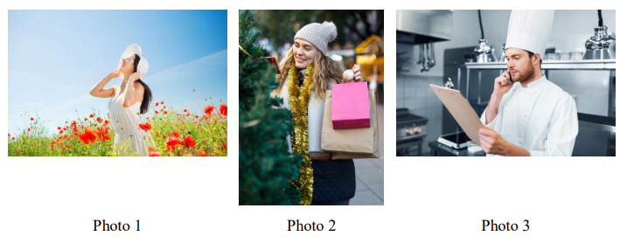

4

Установите соответствие между текстами и их темами, выбрав тему из выпадающего списка. Используйте каждую тему только один раз. В задании одна тема лишняя.
This text deals with …
1. Computer virus.
2. Game addiction.
3. A crime.
4. An important message.
5. Punishment.
6. Using neighbours’ wi-fi.

A. A Singapore teenager who used his neighbours’ wi-fi Internet network will not be able to use the Internet for the next 12 months. The message for wi-fi users is clear: if it isn’t yours, don’t use it.
B. Seventeen-year-old Tan Luo was an online-game fan and played games at all hours of the day. He didn’t have time to study and wasn’t able to complete his course at the college. In the end, his parents were very worried and they disconnected their Internet access so Tan couldn’t go online.
С. However, this didn’t stop him. He knew his neighbours had Internet access, so he used theirs. He was able to connect to their wireless Internet network, or ‘wi-fi’, and continued playing online games from his own home.
D. The neighbours noticed Tan was using their wi-fi one night. They told him to stop, but he didn’t, and so they called the police. In Singapore it’s a crime to use a wi-fi network that isn’t yours. So, the young wi-fi thief had to go to court.
E. In court, Tan said he was very sorry. The judge didn’t sent him to prison. Instead, he sent Tan to a boys’ hostel for nine months. At the hostel, he will do sports and other activities, but he won’t be allowed to play video games. Furthermore, he won’t be able to use the Internet for the next year.
Запишите в таблицу выбранные цифры под соответствующими буквами.
Ответ:
A | B | C | D | E

5

Прочитайте текст и вставьте вместо каждого пропуска нужную грамматическую форму, выбрав её из выпадающего списка.
History of London
The history of London goes back thousands of years. In those ancient times the first inhabitants, Celtic tribes, made A_________ homes on the river Thames. Next B_________ Germanic tribes — the Angles, the Saxons and the Jutes. In 43 AD the Romans invaded Britain. They C_________ a bridge across the Thames. D_________ they decided it was a good place to build a port. Around 50 AD the Romans founded a town by the bridge. Its name is derived from the Celtic word "Londinios," which E_________the place of the brave. So, London was born.

A 1) theirs 2) they 3) their 4) them
B 1) comes 2) came 3) was coming 4) have come
C 1) build 2) were building 3) built 4) have built
D 1) Later 2) Late 3) Last 4) Latest
E 1) mean 2) has meant 3) means 4) is meaning
Запишите в таблицу выбранные цифры под соответствующими буквами.
Ответ:
A | B | C | D | E

6

Прочитайте текст и вставьте вместо каждого пропуска подходящее слово, выбрав его из выпадающего списка. Два слова в списке лишние.Princess Diana
I will never forget what I (A)____ when I heard about the death of Princess Diana. It was Sunday morning and I (B)____ sleep. I got up and switched the radio on. The woman on the radio said: ‘We (C)____ this morning’s programmes to bring you the news of the death of Diana, Princess of Wales. I (D)____ a terrible shock. That morning I telephoned about 25 people. Everyone (E)____ in deep shock. We didn`t know what to do. Eventually my sister and I decided to go to Kensington Palace, where Diana lived. When we arrived, people there were putting flowers at the palace gates. A lot of people were crying and embracing each other.
1) endless; 2) felt; 3) was; 4) have changed; 5) could not; 6) romantic; 7) was doing.
Запишите в таблицу выбранные цифры под соответствующими буквами.
Ответ:
A | B | C | D | E

